# **Difference between Application Server and Web Server in Java:**

On Java J2EE perspective main difference between web server and application server is support of EJB. In order to run EJB or host enterprise Java application (.ear) file you need an application server like JBoss, WebLogic, WebSphere or Glassfish, while you can still run your servlet and JSP or java web application (.war) file inside any web server like Tomcat or Jetty.

1. Application Server supports distributed transaction and EJB. While Web Server only supports Servlets and JSP.

2. Application Server can contain web server in them. most of App server e.g. JBoss or WAS has Servlet and JSP container.

3. Though its not limited to Application Server but they used to provide services like Connection pooling, Transaction management, messaging, clustering, load balancing and persistence. Now Apache tomcat also provides connection pooling.

4. web server is supposed to provide http protocol level service while application server provides support to web service and expose business level service e.g. EJB.

5. Application server are more heavy than web server in terms of resource utilization.

# **String:**

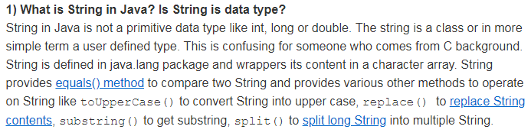

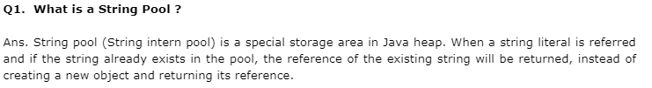

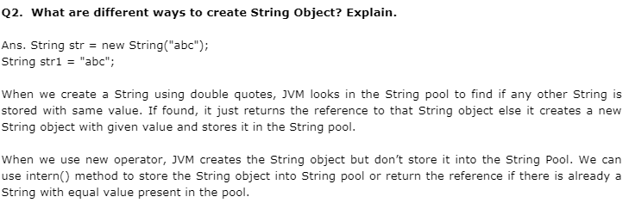

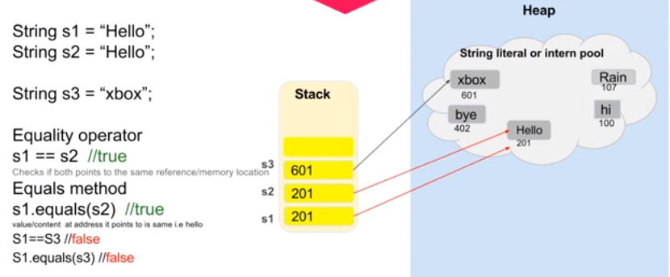

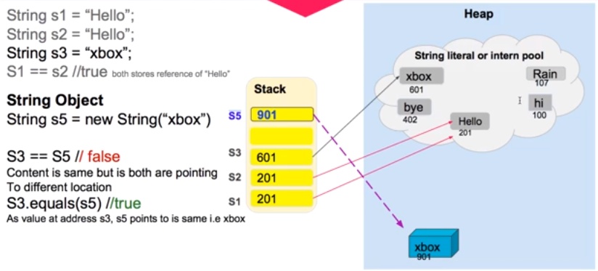

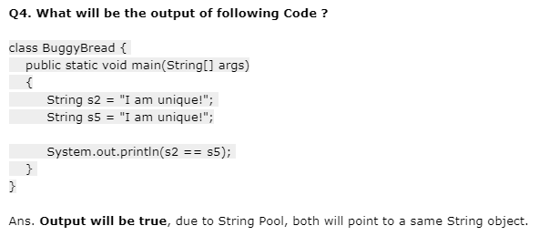

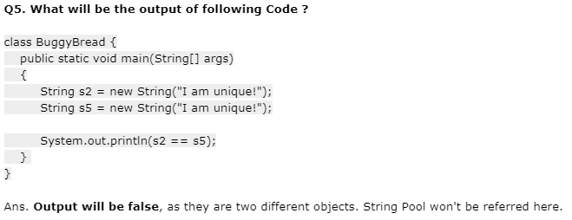

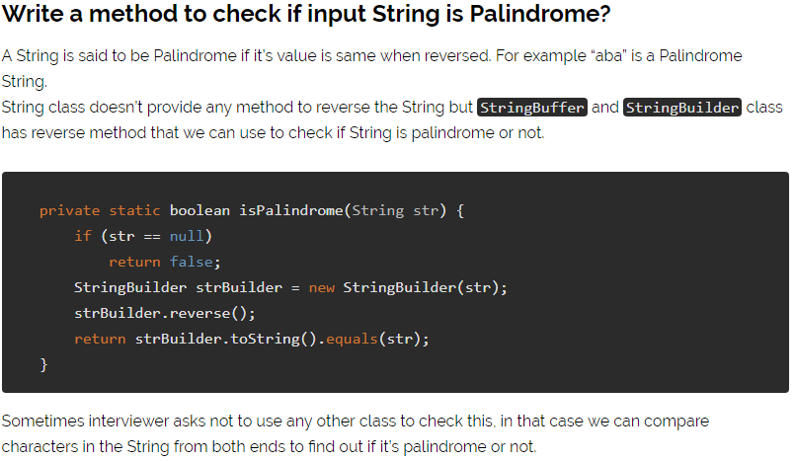

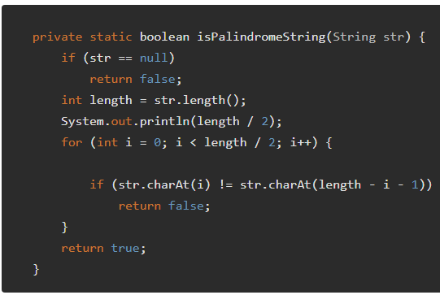

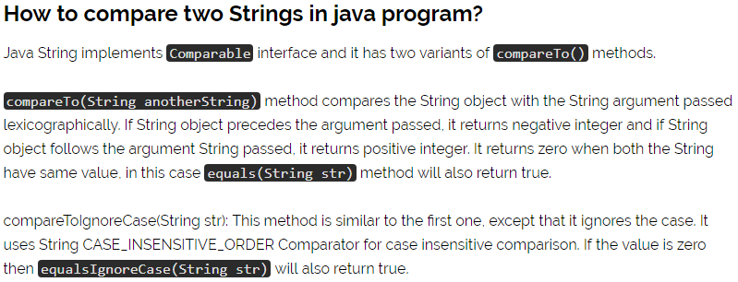

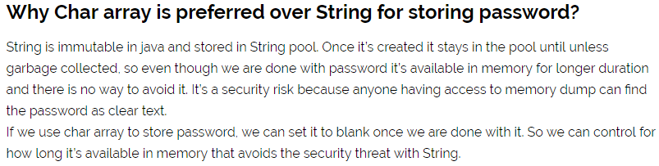

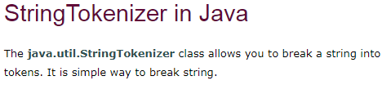

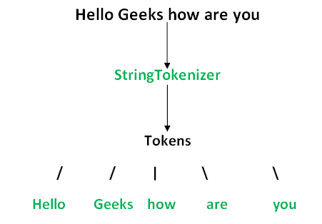

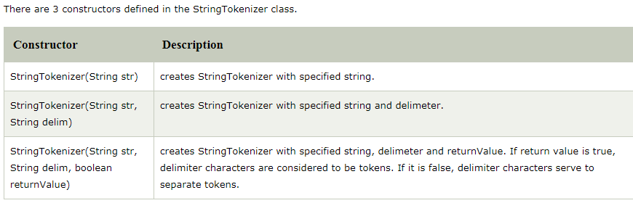

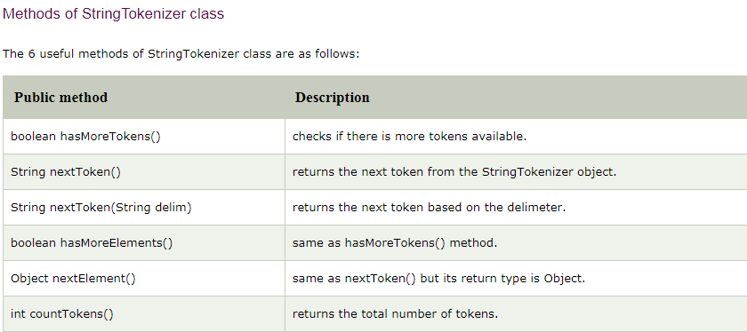

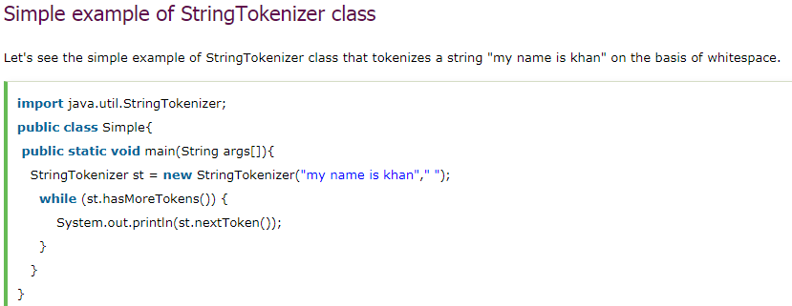

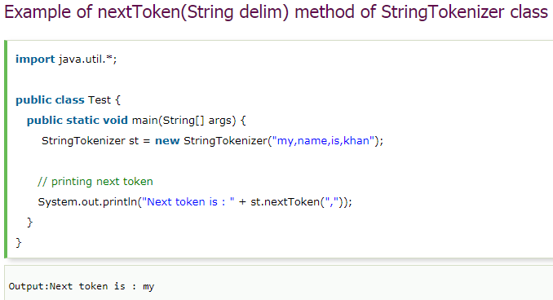

# **How do you prevent SQL Injection in Java Code?**

You can use PreparedStatement to avoid SQL injection in Java code. Use of the PreparedStatement for executing SQL queries not only provides better performance but also shield your Java and J2EE application from SQL Injection attack.

